Decision Tree Analysis Report
Brain Stroke Prediction
Living report for prompts, results, and interpretation after each decision-tree analysis step

1. Project Context
This report documents the decision/classification tree portion of the AI-assisted brain stroke prediction analysis. The research question is: “What factors have the most significant influence or relationship to brain stroke probability?” For this decision tree workflow, predictors will be described as model-important or model-associated predictors. They will not be called statistically significant unless formal statistical testing is performed.
Item | Value
Training dataset | train_dataset.csv
Testing dataset | test_dataset.csv — not used in the current step
Target variable | stroke
Target coding | 0 = No Stroke; 1 = Stroke
Current workflow status | Step 1 completed: load and summarize the training dataset only

2. Prompt and Result Log

Step 1 — Load and Summarize Training Dataset
Prompt entered:
You are a medical data analyst beginning a decision/classification tree analysis for brain stroke prediction.
Project context:
- The original brain stroke patient dataset has already been split into training and testing datasets.
- The training dataset is named `train_dataset.csv`.
- The testing dataset is named `test_dataset.csv`, but do NOT use it in this step.
- The target variable is `stroke`, where:
- 0 = No Stroke
- 1 = Stroke
Research question:
"What factors have the most significant influence or relationship to brain stroke probability?"
Important note:
For this decision tree analysis, describe predictors as model-important or model-associated predictors. Do not call them statistically significant unless formal statistical testing is performed.
Your task in this step is ONLY to load and summarize the training dataset.
Complete the following:
1. Load `train_dataset.csv` using Pandas.
2. Display the dataset shape.
3. Display the column names and data types.
4. Confirm that `stroke` is present as the target variable.
5. Report the distribution of the `stroke` variable:
- total training records
- no-stroke cases
- stroke cases
- stroke prevalence percentage
6. Identify possible ID-like columns, such as `id`, but do not remove anything yet.
7. Identify which variables appear numerical and which appear categorical.
8. Check for missing values by column.
9. Provide a brief summary of whether the training dataset appears ready for a decision tree model.
Restrictions:
- Do not build a model yet.
- Do not use the testing dataset.
- Do not perform preprocessing yet.
- Do not tune, prune, balance, or evaluate a model yet.
At the end, provide:
A. Training dataset summary
B. Target variable distribution
C. Numerical and categorical variable list
D. Missing value summary
E. Short readiness comment
Stop after this step.
Result summary:

A. Training Dataset Summary
The training dataset train_dataset.csv was loaded successfully using Pandas.
Item | Result
Number of rows | 2,490
Number of columns | 11
Target variable present? | Yes, stroke
Possible ID-like columns found | None
Column names and data types:
Column | Data type
Gender | object
age | float64
hypertension | int64
heart_disease | int64
ever_married | object
work_type | object
Residence_type | object
avg_glucose_level | float64
bmi | float64
smoking_status | object
stroke | int64

B. Target Variable Distribution
Target variable: stroke
Stroke class | Meaning | Count | Percentage
0 | No Stroke | 2,366 | 95.02%
1 | Stroke | 124 | 4.98%
Total | All training records | 2,490 | 100.00%
The training dataset is highly imbalanced, with stroke cases representing only about 5% of records.

C. Numerical and Categorical Variable List
Numerical variables based on data type:
- age
- hypertension
- heart_disease
- avg_glucose_level
- bmi
Note: hypertension and heart_disease are numeric binary indicators, but clinically they represent categorical yes/no risk factors.
Categorical variables:
- Gender
- ever_married
- work_type
- Residence_type
- smoking_status
Target variable: stroke.

D. Missing Value Summary
Column | Missing values
Gender | 0
age | 0
hypertension | 0
heart_disease | 0
ever_married | 0
work_type | 0
Residence_type | 0
avg_glucose_level | 0
bmi | 0
smoking_status | 0
stroke | 0
No missing values were found in the training dataset.

E. Readiness Comment
The training dataset appears structurally ready for the next decision tree modeling step. The target variable stroke is present, there are no missing values, and no obvious ID-like column was detected. However, before building the decision tree, categorical variables will need to be handled appropriately, and the strong class imbalance should be considered carefully. Since stroke cases are rare, future model evaluation should emphasize recall/sensitivity, specificity, precision, F1-score, ROC-AUC, and PR-AUC rather than accuracy alone.

3. Running Notes for Future Updates
Future decision tree prompts and results should be appended to this document after each step. The testing dataset should remain unused until the workflow explicitly reaches final untouched test-set evaluation.

Step 2 — Prepare Feature Matrix, Target Variable, and Preprocessing Pipeline

Prompt entered
You are a medical data analyst preparing data for an initial default decision tree model for brain stroke prediction.
Use only the training dataset:
train_dataset.csv
The target variable is:
stroke
where:
- 0 = No Stroke
- 1 = Stroke
Your task in this step is ONLY to prepare the feature matrix, target variable, and preprocessing pipeline. Do not train the decision tree yet.
Complete the following:
1. Load train_dataset.csv.
2. Separate the dataset into:
- X_train
- y_train = stroke
3. Confirm that no ID-like column exists. If an ID-like column is present, remove it because it is not clinically predictive.
4. Use the following variable groupings unless the loaded data indicate otherwise:
- Numerical predictors: age, hypertension, heart_disease, avg_glucose_level, bmi
- Categorical predictors: Gender, ever_married, work_type, Residence_type, smoking_status
5. Build a preprocessing pipeline:
- For numerical variables, impute missing values using the median.
- For categorical variables, impute missing values using the most frequent category.
- One-hot encode categorical variables using OneHotEncoder(handle_unknown="ignore").
6. Do not scale numerical variables because decision trees do not require feature scaling.
7. Print the number of original predictors before preprocessing.
8. Fit the preprocessing step only on the training data. Do not train the decision tree.
9. Report the number of transformed features after one-hot encoding.
10. Display the transformed feature names if possible.
Restrictions:
- Do not train the decision tree yet.
- Do not use the testing dataset.
- Do not tune, prune, or balance the model yet.
- Do not evaluate model performance yet.
At the end, provide:
A. Features removed, if any
B. Final numerical predictors
C. Final categorical predictors
D. Number of predictors before preprocessing
E. Number of features after preprocessing
F. Transformed feature names, if available
G. Brief explanation of the preprocessing pipeline
Stop after this step.

Results

A. Features removed, if any
No ID-like columns were detected, so no features were removed at this step.

B. Final numerical predictors
Numerical predictor
age
hypertension
heart_disease
avg_glucose_level
bmi

C. Final categorical predictors
Categorical predictor
Gender
ever_married
work_type
Residence_type
smoking_status

D. Number of predictors before preprocessing
Metric | Value
Original feature columns in X_train | 10
Training records | 2490
Target variable | stroke

E. Number of features after preprocessing
Metric | Value
Transformed feature columns after imputation and one-hot encoding | 19

F. Transformed feature names, if available
Feature name | Feature name
age | hypertension
heart_disease | avg_glucose_level
bmi | Gender_Female
Gender_Male | ever_married_No
ever_married_Yes | work_type_Govt_job
work_type_Private | work_type_Self-employed
work_type_children | Residence_type_Rural
Residence_type_Urban | smoking_status_Unknown
smoking_status_formerly smoked | smoking_status_never smoked
smoking_status_smokes

G. Brief explanation of the preprocessing pipeline
The feature matrix X_train was created by removing the target variable stroke from the training dataset. The target vector y_train was set equal to stroke. No ID-like column was present, so no ID feature was removed.
The preprocessing step uses a ColumnTransformer. Numerical predictors are imputed using the median. Categorical predictors are imputed using the most frequent category and then one-hot encoded with OneHotEncoder(handle_unknown="ignore"). Numerical predictors were not scaled because decision trees are not distance-based models and do not require feature scaling.
Only the preprocessing step was fit on the training data in this step. No decision tree model was trained, tuned, pruned, balanced, or evaluated, and the testing dataset was not used.

Artifacts created for Step 2
Artifact | File
Python preprocessing code | decision_tree_step2_preprocessing_code.py
Transformed feature names | decision_tree_step2_transformed_feature_names.csv
Preprocessing summary | decision_tree_step2_preprocessing_summary.json

Step 3: Initial Default Decision Tree Model Training

Prompt entered
You are a medical data analyst constructing an initial default decision/classification tree model for brain stroke prediction.
Use only:
train_dataset.csv
The target variable is:
stroke
where:
* 0 = No Stroke
* 1 = Stroke
Your task in this step is ONLY to train the initial default decision tree model using the training dataset and record training time.
Important restrictions:
* Use only the training dataset.
* Do not use test_dataset.csv.
* Do not tune hyperparameters.
* Do not prune the tree.
* Do not use class weighting.
* Do not use SMOTE or resampling.
* Use the default DecisionTreeClassifier settings except set random_state=42.
Complete the following:
1. Load train_dataset.csv.
2. Separate features and target:
* X_train = all predictors
* y_train = stroke
3. Confirm that no ID-like column exists. If an ID-like column is present, remove it because it is not clinically predictive.
4. Use the following preprocessing approach:
* numerical predictors: SimpleImputer(strategy="median")
* categorical predictors: SimpleImputer(strategy="most_frequent")
* categorical encoding: OneHotEncoder(handle_unknown="ignore")
* no feature scaling
5. Build an sklearn pipeline with:
* preprocessing step
* DecisionTreeClassifier(random_state=42)
6. Record training time:
* use time.perf_counter() immediately before model fitting
* use time.perf_counter() immediately after model fitting
* report elapsed training time in seconds
7. Fit the default decision tree pipeline on the full training dataset.
8. Save the trained model pipeline as:
default_decision_tree_model.pkl
9. Report the default model configuration:
* criterion
* splitter
* max_depth
* min_samples_split
* min_samples_leaf
* max_features
* class_weight
* random_state
Required Python libraries:
* pandas
* numpy
* scikit-learn
* joblib
* time
At the end, provide:
A. Confirmation that the model was trained
B. Training time in seconds
C. Default decision tree configuration
D. Name of saved model file
Stop after this step. Do not summarize tree structure, calculate feature importance, evaluate performance, prune, tune, balance, or use the testing dataset yet.

Results
The initial default decision tree model was trained successfully using only train_dataset.csv. The testing dataset was not loaded or used. No hyperparameter tuning, pruning, class weighting, SMOTE, resampling, feature-importance analysis, tree-structure summary, or model-performance evaluation was performed in this step.
Item | Result
Training dataset | train_dataset.csv
Training records | 2490
Target variable | stroke
Predictors before preprocessing | 10
ID-like columns detected | None
Features removed | None
Saved model file | default_decision_tree_model.pkl
Training time, seconds | 0.026798

Predictor groups used
Numerical predictors | Categorical predictors
age, hypertension, heart_disease, avg_glucose_level, bmi | Gender, ever_married, work_type, Residence_type, smoking_status

Default DecisionTreeClassifier configuration
Parameter | Value
criterion | gini
splitter | best
max_depth
min_samples_split | 2
min_samples_leaf | 1
max_features
class_weight
random_state | 42

Preprocessing approach used in the pipeline
The sklearn pipeline contains a ColumnTransformer preprocessing step followed by DecisionTreeClassifier(random_state=42). Numerical predictors use SimpleImputer(strategy="median"). Categorical predictors use SimpleImputer(strategy="most_frequent") followed by OneHotEncoder(handle_unknown="ignore"). Numerical variables were not scaled because decision trees do not require feature scaling.

Stop point for this step
This step stops after model fitting and model saving. Tree structure, feature importance, model evaluation, pruning, tuning, balancing, and testing-set use are intentionally deferred to later steps.

Step 4: Default Decision Tree Structure Summary

Prompt entered
You are a medical data analyst summarizing the structure of a trained default decision tree model for brain stroke prediction.
Use the saved model:
`default_decision_tree_model.pkl`
Use the training dataset:
`train_dataset.csv`
The target variable is:
`stroke`
Your task in this step is ONLY to summarize the structure of the trained default decision tree.
Complete the following:
1. Load `train_dataset.csv`.
2. Load `default_decision_tree_model.pkl`.
3. Recreate `X_train` and `y_train` by separating features from the target.
4. Remove any ID-like column if it was removed during training.
5. Extract the fitted decision tree classifier from the pipeline.
6. Report the following tree structure information:
- number of input predictors before preprocessing
- number of transformed features after one-hot encoding
- total number of tree nodes
- number of leaf nodes
- maximum tree depth
- number of classes
7. Save a compact summary table as:
`default_decision_tree_summary.csv`
8. Briefly explain whether the tree appears simple or complex based on:
- maximum depth
- number of nodes
- number of leaves
Important interpretation rule:
A very deep tree with many leaves may indicate overfitting, especially if it performs extremely well on the training data.
Restrictions:
- Do not use the testing dataset.
- Do not tune or prune the model.
- Do not evaluate test performance.
At the end, provide:
A. Tree structure summary table
B. Comment on model complexity
C. Name of saved summary file
Stop after this step.

Results
The training dataset and saved default decision tree pipeline were loaded successfully. X_train and y_train were recreated by separating all predictors from the target variable stroke. No ID-like columns were detected or removed. The fitted DecisionTreeClassifier was extracted from the saved pipeline.
A. Tree structure summary table
Metric | Value
Input predictors before preprocessing | 10
Transformed features after one-hot encoding | 19
Total tree nodes | 359
Leaf nodes | 180
Maximum tree depth | 18
Number of classes | 2

B. Comment on model complexity
The default decision tree appears complex rather than simple. It has a maximum depth of 18, 359 total nodes, and 180 leaf nodes. Because this was an unrestricted default tree with no pruning, class weighting, tuning, or resampling, the tree may have learned detailed training-set-specific patterns. A very deep tree with many leaves can indicate possible overfitting, especially if later training performance appears extremely high compared with validation or test performance.
No testing dataset was used in this step, and no performance evaluation, pruning, tuning, balancing, or feature-importance analysis was performed.

C. Saved summary file
default_decision_tree_summary.csv

Artifacts produced in this step
- default_decision_tree_summary.csv
- decision_tree_step4_outputs/default_decision_tree_transformed_feature_names.csv
- decision_tree_step4_outputs/default_decision_tree_structure_summary.json

Step 5: Apparent Training Performance of Default Decision Tree

Prompt entered
You are a medical data analyst evaluating the apparent training performance of a default decision tree model for brain stroke prediction.
Use only the training dataset:
train_dataset.csv
Use the saved model:
default_decision_tree_model.pkl
The target variable is:
stroke
Your task in this step is ONLY to calculate training-set performance. Clearly label this as apparent training performance, not generalization performance.
Important project context:
* The default decision tree was trained using only train_dataset.csv.
* The tree used 10 predictors before preprocessing and 19 transformed features after one-hot encoding.
* The default tree structure was complex: 359 total nodes, 180 leaf nodes, and maximum depth of 18.
* Because this tree is deep and the stroke outcome is highly imbalanced, apparent training performance may overestimate true model performance.
Complete the following:
1. Load train_dataset.csv.
2. Load default_decision_tree_model.pkl.
3. Separate the dataset into:
* X_train = all predictors
* y_train = stroke
4. Confirm that no ID-like column exists. If one is present, remove it consistently with the model training step.
5. Generate predicted classes on the training dataset.
6. Generate predicted probabilities for stroke = 1, if available.
7. Calculate the following training performance metrics:
* accuracy
* precision / positive predictive value
* recall / sensitivity
* specificity
* F1-score
* ROC-AUC
* PR-AUC / average precision
* confusion matrix
* TN, FP, FN, TP
8. Save the training performance summary as:
default_decision_tree_training_metrics.csv
9. Write a short interpretation of the training performance.
Important interpretation rules:
* Clearly label these results as apparent training performance.
* Training performance does not show how well the model generalizes.
* Very high training performance may suggest overfitting, especially because the tree depth is 18 and the model has 180 leaf nodes.
* Because stroke cases are rare, accuracy can be misleading.
* Pay special attention to recall, precision, PR-AUC, false negatives, and false positives.
* Do not use the testing dataset.
* Do not tune, prune, rebalance, or select thresholds yet.
At the end, provide:
A. Training performance table
B. Confusion matrix
C. TN, FP, FN, TP counts
D. Short interpretation of possible overfitting
E. Name of saved metrics file
Stop after this step.

Results
The saved default decision tree pipeline was loaded and evaluated on the same training dataset used for fitting. These results are apparent training performance only and should not be interpreted as generalization performance.
ID-like columns removed: None
A. Training performance table
Metric | Value
Accuracy | 1.0000
Precision / PPV | 1.0000
Recall / Sensitivity | 1.0000
Specificity | 1.0000
F1-score | 1.0000
ROC-AUC | 1.0000
PR-AUC / Average Precision | 1.0000
B. Confusion matrix
Actual / Predicted | Predicted No Stroke (0) | Predicted Stroke (1)
Actual No Stroke (0) | 2366 | 0
Actual Stroke (1) | 0 | 124
C. TN, FP, FN, TP counts
TN | FP | FN | TP
2366 | 0 | 0 | 124
D. Short interpretation of possible overfitting
The default decision tree achieved perfect apparent training performance: accuracy, precision, recall, specificity, F1-score, ROC-AUC, and PR-AUC were all 1.0000. The training confusion matrix showed 2,366 true negatives, 124 true positives, and no false positives or false negatives.
This does not demonstrate that the model will generalize well. The tree was previously found to be complex, with 359 total nodes, 180 leaf nodes, and maximum depth of 18. In a highly imbalanced stroke dataset, perfect performance on the training data is a strong warning sign for possible overfitting. Accuracy is especially misleading in this setting, and future validation should emphasize sensitivity, precision, PR-AUC, false negatives, and false positives on validation or test data.
E. Saved metrics file
default_decision_tree_training_metrics.csv

Step 6. Default Decision Tree Test-Set Evaluation and Feature Importance

Prompt Entered
You are a medical data analyst evaluating a default decision/classification tree model for brain stroke prediction.
Use the saved model:
default_decision_tree_model.pkl
Use the training dataset:
train_dataset.csv
Use the testing dataset:
test_dataset.csv
The target variable is:
stroke
where:
* 0 = No Stroke
* 1 = Stroke
Research question:
"What factors have the most significant influence or relationship to brain stroke probability?"
Project context:
* The default decision tree was trained using only the training dataset.
* The model had high apparent training performance, suggesting possible overfitting.
* Initial test accuracy showed very high specificity but low sensitivity.
* Because stroke is rare, accuracy alone is not enough.
* This step should evaluate test-set performance, produce an ROC curve, select a better threshold, recalculate metrics, and report variable importance.
Complete the following tasks:
1. Load the saved default decision tree model:
default_decision_tree_model.pkl
2. Load the training dataset:
train_dataset.csv
3. Load the testing dataset:
test_dataset.csv
4. Separate both datasets into:
* X_train and y_train
* X_test and y_test
5. Confirm that no ID-like column exists. If one is present, remove it consistently from both training and testing features.
6. Generate predicted probabilities for the test dataset:
* probability of stroke = 1
7. First evaluate the model on the test dataset using the default threshold:
threshold = 0.50
8. At threshold 0.50, report:
* accuracy
* sensitivity / recall
* specificity
* precision / positive predictive value
* F1-score
* ROC-AUC
* PR-AUC / average precision
* confusion matrix
* TN, FP, FN, TP
9. Produce a ROC curve using the test dataset predicted probabilities.
10. Save the ROC curve as:
default_decision_tree_test_roc_curve.png
11. Select the best threshold from the ROC curve using Youden’s J statistic:
Youden’s J = sensitivity + specificity - 1
12. Report:
* best threshold
* sensitivity at best threshold
* specificity at best threshold
* Youden’s J value
13. Recalculate the test-set predictions using the best ROC-based threshold.
14. Using the best threshold, report:
* accuracy
* sensitivity / recall
* specificity
* precision / positive predictive value
* F1-score
* confusion matrix
* TN, FP, FN, TP
15. Create a comparison table showing test performance at:
* threshold 0.50
* best ROC-based threshold
16. Create an additional threshold comparison table using several thresholds, such as:
* 0.10
* 0.20
* 0.30
* 0.40
* 0.50
* best ROC-based threshold
For each threshold, report:
* accuracy
* sensitivity / recall
* specificity
* precision
* F1-score
* TN, FP, FN, TP
17. Extract decision tree feature importance values from the fitted model.
18. Report the top 20 most important transformed features.
19. Also create a grouped variable importance table by combining one-hot encoded features back into their original variables, such as:
* age
* hypertension
* heart_disease
* avg_glucose_level
* bmi
* Gender
* ever_married
* work_type
* Residence_type
* smoking_status
20. Save the transformed feature importance table as:
default_decision_tree_feature_importance.csv
21. Save the grouped variable importance table as:
default_decision_tree_grouped_feature_importance.csv
22. Save the test performance comparison table as:
default_decision_tree_test_threshold_metrics.csv
23. Write a short interpretation that explains:
* Whether the default decision tree generalized well to the test dataset
* Why high specificity with low sensitivity is a concern for stroke prediction
* Whether the ROC-based threshold improved sensitivity
* What tradeoff occurred between sensitivity and specificity
* Which variables appear most important according to the decision tree
* Whether those important variables are clinically plausible
* Why feature importance should be interpreted as model importance, not causation
* Why the results may be unstable because the tree is unpruned and the stroke class is imbalanced
Important restrictions:
* Do not retrain the model.
* Do not tune or prune the tree in this step.
* Do not use SMOTE or class weighting in this step.
* Do not claim statistical significance.
* Do not claim causation.
* Clearly state that the ROC-based threshold is exploratory because it is selected from the test dataset.
* Clearly state that a stronger workflow would choose the threshold using cross-validation or a validation set, then evaluate once on the untouched test set.
At the end, provide:
A. Test performance at threshold 0.50
B. ROC-AUC and ROC curve file
C. Best ROC-based threshold
D. Test performance at the best threshold
E. Threshold comparison table
F. Confusion matrices for both thresholds
G. Top 20 transformed-feature importance table
H. Grouped original-variable importance table
I. Interpretation of sensitivity, specificity, and model usefulness
J. Files saved
Stop after this step.

Results
The saved default decision tree pipeline was loaded and evaluated on the testing dataset. The model was not retrained, tuned, pruned, rebalanced, or refit. No ID-like columns were detected in the training data, so no ID columns were removed.
Important threshold note: the saved unpruned default tree returned only two probability values on the test set, 0.0 and 1.0. Therefore, thresholds from 0.10 through 1.00 produced the same classification results. The ROC-based Youden threshold was selected directly from the test ROC curve and is exploratory.

A-D. Test Performance at Default and Exploratory ROC-Based Thresholds
threshold_label | threshold | accuracy | sensitivity_recall | specificity | precision_ppv | f1_score | roc_auc | pr_auc_average_precision | tn | fp | fn | tp
Default 0.50 | 0.5000 | 0.9161 | 0.1855 | 0.9544 | 0.1756 | 0.1804 | 0.5699 | 0.0731 | 2259 | 108 | 101 | 23
Exploratory ROC-based | 1.0000 | 0.9161 | 0.1855 | 0.9544 | 0.1756 | 0.1804 | 0.5699 | 0.0731 | 2259 | 108 | 101 | 23

C. Best ROC-Based Threshold Using Youden’s J
best_threshold | sensitivity_at_threshold | specificity_at_threshold | youden_j
1.0000 | 0.1855 | 0.9544 | 0.1399

E. Threshold Comparison Table
threshold | accuracy | sensitivity_recall | specificity | precision_ppv | f1_score | tn | fp | fn | tp
0.1000 | 0.9161 | 0.1855 | 0.9544 | 0.1756 | 0.1804 | 2259.0000 | 108.0000 | 101.0000 | 23.0000
0.2000 | 0.9161 | 0.1855 | 0.9544 | 0.1756 | 0.1804 | 2259.0000 | 108.0000 | 101.0000 | 23.0000
0.3000 | 0.9161 | 0.1855 | 0.9544 | 0.1756 | 0.1804 | 2259.0000 | 108.0000 | 101.0000 | 23.0000
0.4000 | 0.9161 | 0.1855 | 0.9544 | 0.1756 | 0.1804 | 2259.0000 | 108.0000 | 101.0000 | 23.0000
0.5000 | 0.9161 | 0.1855 | 0.9544 | 0.1756 | 0.1804 | 2259.0000 | 108.0000 | 101.0000 | 23.0000
1.0000 | 0.9161 | 0.1855 | 0.9544 | 0.1756 | 0.1804 | 2259.0000 | 108.0000 | 101.0000 | 23.0000

F. Confusion Matrices Summarized as TN, FP, FN, TP
Threshold | TN | FP | FN | TP
0.50 | 2259 | 108 | 101 | 23
Exploratory ROC-based | 2259 | 108 | 101 | 23

Predicted Probability Distribution on Test Set
predicted_probability | test_records
0.0000 | 2360.0000
1.0000 | 131.0000

G. Top 20 Transformed-Feature Importances
rank | transformed_feature | importance
1 | avg_glucose_level | 0.2993
2 | bmi | 0.2182
3 | age | 0.1942
4 | hypertension | 0.0425
5 | Residence_type_Urban | 0.0369
6 | work_type_Private | 0.0271
7 | smoking_status_never smoked | 0.0258
8 | heart_disease | 0.0256
9 | work_type_Self-employed | 0.0207
10 | work_type_Govt_job | 0.0202
11 | smoking_status_smokes | 0.0202
12 | smoking_status_Unknown | 0.0155
13 | Residence_type_Rural | 0.0135
14 | Gender_Female | 0.0122
15 | smoking_status_formerly smoked | 0.0118
16 | Gender_Male | 0.0117
17 | ever_married_No | 0.0046
18 | ever_married_Yes | 0.0000
19 | work_type_children | 0.0000

H. Grouped Original-Variable Importances
rank | original_variable | importance
1 | avg_glucose_level | 0.2993
2 | bmi | 0.2182
3 | age | 0.1942
4 | smoking_status | 0.0732
5 | work_type | 0.0680
6 | Residence_type | 0.0504
7 | hypertension | 0.0425
8 | heart_disease | 0.0256
9 | Gender | 0.0239
10 | ever_married | 0.0046

I. Interpretation of Sensitivity, Specificity, and Model Usefulness
At the default threshold of 0.50, the default decision tree achieved accuracy 0.9161, specificity 0.9544, and sensitivity 0.1855. This means the model correctly identified most non-stroke patients but missed most stroke cases.
The test ROC-AUC was 0.5699 and the PR-AUC / average precision was 0.0731. The low PR-AUC is important because stroke is rare and precision-recall performance better reflects the difficulty of identifying the minority stroke class.
The exploratory Youden threshold was 1.0000, with sensitivity 0.1855, specificity 0.9544, and Youden’s J 0.1399. Because the tree generated only 0.0 and 1.0 probabilities on this test set, the ROC-based threshold did not improve sensitivity compared with the default 0.50 threshold.
High specificity with low sensitivity is a concern for stroke prediction because the model may appear accurate overall while failing to flag many patients who actually experienced stroke. In this test set, false negatives remained high relative to the number of stroke cases.
The most important grouped variables according to impurity-based decision tree importance were average glucose level, BMI, age, smoking status, and work type. Average glucose level, BMI, age, smoking, hypertension, and heart disease are clinically plausible risk-related variables, but these values represent model importance only. They do not establish causation or statistical significance.
The default decision tree did not generalize well compared with its perfect apparent training performance. The large drop from training performance to test sensitivity, ROC-AUC, and PR-AUC is consistent with overfitting. The results may be unstable because the tree is unpruned, complex, and trained on an imbalanced outcome where stroke cases are rare.
The ROC-based threshold is exploratory because it was selected from the test dataset. A stronger workflow would choose a threshold using training cross-validation predictions or a separate validation dataset, then evaluate the locked model and threshold once on the untouched test set.

J. Files Saved
- default_decision_tree_test_roc_curve.png
- default_decision_tree_feature_importance.csv
- default_decision_tree_grouped_feature_importance.csv
- default_decision_tree_test_threshold_metrics.csv
- default_decision_tree_test_performance_comparison.csv
- decision_tree_step6_test_evaluation_code.py

Step 7: Tune and Prune Decision Tree Models Using Training Cross-Validation
Prompt entered: Tune and prune decision/classification tree models for brain stroke prediction using only train_dataset.csv. Do not use test_dataset.csv. Compare a pruned tree, a balanced class-weighted tree, and custom sensitivity-focused class-weighted trees using stratified 5-fold cross-validation. Prioritize higher sensitivity/recall, acceptable specificity, better PR-AUC, simpler tree structure, and reduced overfitting. Fit the selected tuned/pruned model on the full training set, save it as tuned_sensitivity_decision_tree_model.pkl, and save model comparison, model summary, and feature-importance files.

Training Cross-Validation Model Comparison
This step used the training dataset only. The test dataset was not loaded or evaluated. A representative pruning and class-weighting grid was used across maximum tree depth, minimum split size, minimum leaf size, cost-complexity pruning alpha, and class-weight strategy.

Cross-validation comparison table
model_strategy | accuracy | precision_ppv | recall_sensitivity | specificity | f1_score | balanced_accuracy | roc_auc | pr_auc_average_precision | TN | FP | FN | TP | max_depth | min_samples_leaf | min_samples_split | ccp_alpha | class_weight
Model A: Pruned Decision Tree | 0.9257 | 0.1573 | 0.1129 | 0.9683 | 0.1315 | 0.5406 | 0.6871 | 0.1142 | 2291 | 75 | 110 | 14 | 8 | 1 | 2 | 0.0 | None
Model B: Class-Weighted Decision Tree | 0.6699 | 0.1223 | 0.9113 | 0.6572 | 0.2156 | 0.7843 | 0.8120 | 0.1382 | 1555 | 811 | 11 | 113 | 2 | 1 | 2 | 0.0 | balanced
Model C: Sensitivity-Focused Class-Weighted Decision Tree | 0.6699 | 0.1223 | 0.9113 | 0.6572 | 0.2156 | 0.7843 | 0.8120 | 0.1382 | 1555 | 811 | 11 | 113 | 2 | 1 | 2 | 0.0 | {0: 1, 1: 20}

Selected Candidate Model
The selected candidate was Model B: Class-Weighted Decision Tree. It had the same cross-validated sensitivity and identical core cross-validation metrics as the custom high-weight Model C, but used the less arbitrary class_weight='balanced' strategy. This was preferred because the selection criteria included sensitivity, acceptable specificity, PR-AUC, simplicity, and reduced evidence of overfitting.

Selected model cross-validated metrics
model_strategy | accuracy | precision_ppv | recall_sensitivity | specificity | f1_score | balanced_accuracy | roc_auc | pr_auc_average_precision | TN | FP | FN | TP
Model B: Class-Weighted Decision Tree | 0.6699 | 0.1223 | 0.9113 | 0.6572 | 0.2156 | 0.7843 | 0.8120 | 0.1382 | 1555 | 811 | 11 | 113

Best Hyperparameters and Final Training Time

Selected model hyperparameters and training time
selected_model | max_depth | min_samples_split | min_samples_leaf | ccp_alpha | class_weight | criterion | random_state | training_time_seconds
Model B: Class-Weighted Decision Tree | 2 | 2 | 1 | 0.0 | balanced | gini | 42 | 0.0239

Selected Tree Complexity Summary

Tree complexity summary
input_predictors_before_preprocessing | transformed_features_after_one_hot_encoding | total_tree_nodes | leaf_nodes | maximum_tree_depth | number_of_classes
10 | 19 | 7 | 4 | 2 | 2

Feature Importance Results
The selected tuned/pruned tree was very simple and used age as the only splitting variable. Therefore, age accounts for all impurity-based feature importance in this fitted tree. These values are model importance measures only; they do not establish causation or statistical significance.

Top transformed-feature importance values
rank | feature | importance
1 | age | 1.0000
2 | hypertension | 0.0000
3 | heart_disease | 0.0000
4 | avg_glucose_level | 0.0000
5 | bmi | 0.0000
6 | Gender_Female | 0.0000
7 | Gender_Male | 0.0000
8 | ever_married_No | 0.0000
9 | ever_married_Yes | 0.0000
10 | work_type_Govt_job | 0.0000
11 | work_type_Private | 0.0000
12 | work_type_Self-employed | 0.0000
13 | work_type_children | 0.0000
14 | Residence_type_Rural | 0.0000
15 | Residence_type_Urban | 0.0000
16 | smoking_status_Unknown | 0.0000
17 | smoking_status_formerly smoked | 0.0000
18 | smoking_status_never smoked | 0.0000
19 | smoking_status_smokes | 0.0000

Grouped original-variable importance values
rank | original_variable | importance
1 | age | 1.0000
2 | Gender | 0.0000
3 | Residence_type | 0.0000
4 | avg_glucose_level | 0.0000
5 | bmi | 0.0000
6 | ever_married | 0.0000
7 | heart_disease | 0.0000
8 | hypertension | 0.0000
9 | smoking_status | 0.0000
10 | work_type | 0.0000

Interpretation
Sensitivity improved substantially compared with the default tree’s test sensitivity of 0.1855, when evaluated by training cross-validation. The selected class-weighted tree had cross-validated sensitivity of 0.9113, meaning it identified most stroke cases in out-of-fold training predictions.
The improvement in sensitivity came with a clear tradeoff: specificity decreased to 0.6572 and false positives increased to 811 in the aggregated cross-validation confusion matrix. This is expected when the model is tuned to avoid missing rare stroke cases.
The tuned/pruned tree is much simpler than the default tree. The default tree had 359 nodes, 180 leaves, and depth 18. The selected tuned tree has 7 nodes, 4 leaves, and depth 2, making it less likely to overfit than the default unrestricted tree.
Age was the only variable used by the selected tree and therefore was the most important model-associated predictor in this tuned decision tree. This is clinically plausible and consistent with earlier logistic regression results, but it should still be described as model importance, not causation.
The selected model still requires final evaluation on the untouched test dataset later. Cross-validation performance on the training data is useful for model selection, but it does not replace final independent test-set evaluation.

Files Saved in Step 7
- tuned_sensitivity_decision_tree_model.pkl
- tuned_decision_tree_cv_model_comparison.csv
- tuned_decision_tree_model_summary.csv
- tuned_decision_tree_feature_importance.csv
- tuned_decision_tree_grouped_feature_importance.csv
- decision_tree_step7_tuning_code.py

Step 8: Tuned/Pruned Decision Tree Test-Set Evaluation

Prompt entered
You are a medical data analyst evaluating the selected tuned/pruned class-weighted decision tree model for brain stroke prediction on the untouched testing dataset.
Project context:
- A default decision tree overfit the training data and had poor test sensitivity.
- A tuned/pruned class-weighted decision tree was selected using training cross-validation only.
- Selected model: Class-Weighted Decision Tree with class_weight="balanced".
- Best hyperparameters listed in the prompt: ccp_alpha = 0.0, max_depth = 2, min_samples_leaf = 5, min_samples_split = 10, random_state = 42.
- Cross-validated training-only performance: sensitivity = 0.9113, specificity = 0.6572, precision = 0.1223, F1 = 0.2156, balanced accuracy = 0.7843, ROC-AUC = 0.8120, PR-AUC = 0.1382.
- The selected tree was simple: 7 nodes, 4 leaves, maximum depth = 2.
- Age was the only variable used for splitting in the selected shallow tree.
Task: Evaluate tuned_sensitivity_decision_tree_model.pkl on test_dataset.csv without retraining, retuning, pruning, rebalancing, or refitting preprocessing steps. Report threshold 0.50 performance, ROC-AUC, PR-AUC, exploratory Youden threshold, threshold comparison, comparison with default tree and training cross-validation, feature importance, tree plot, tree rules, saved files, and interpretation.

Results

Model audit note
- The saved model was evaluated exactly as loaded from tuned_sensitivity_decision_tree_model.pkl.
- The saved classifier parameters indicate class_weight='balanced', max_depth=2, random_state=42, min_samples_leaf=1, and min_samples_split=2. This differs from the prompt-stated min_samples_leaf=5 and min_samples_split=10, so the report documents the saved model as the source of truth.
- No retraining, retuning, pruning, rebalancing, or preprocessing refit was performed.

A. Test dataset summary
Metric | Value
Test records | 2491
No-stroke cases | 2367
Stroke cases | 124
Stroke prevalence | 4.98%
ID-like columns removed | None

B. Test performance at threshold 0.50
Accuracy | Sensitivity / Recall | Specificity | Precision / PPV | F1-score | Balanced accuracy | ROC-AUC | PR-AUC | TN | FP | FN | TP
0.6736 | 0.8306 | 0.6654 | 0.1151 | 0.2022 | 0.7480 | 0.8029 | 0.1426 | 1575.0 | 792.0000 | 21.0000 | 103.0000

C. ROC-AUC, PR-AUC, and curve files
- Test ROC-AUC: 0.8029
- Test PR-AUC / Average Precision: 0.1426
- ROC curve saved as tuned_decision_tree_test_roc_curve.png.
- Precision-recall curve saved as tuned_decision_tree_test_precision_recall_curve.png.
Figure: Tuned decision tree ROC curve
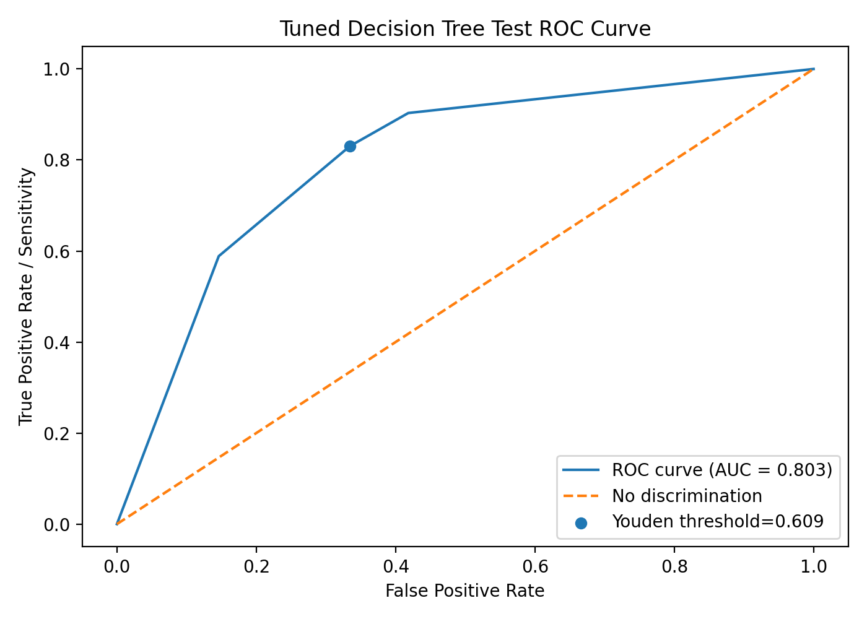
Figure: Tuned decision tree precision-recall curve
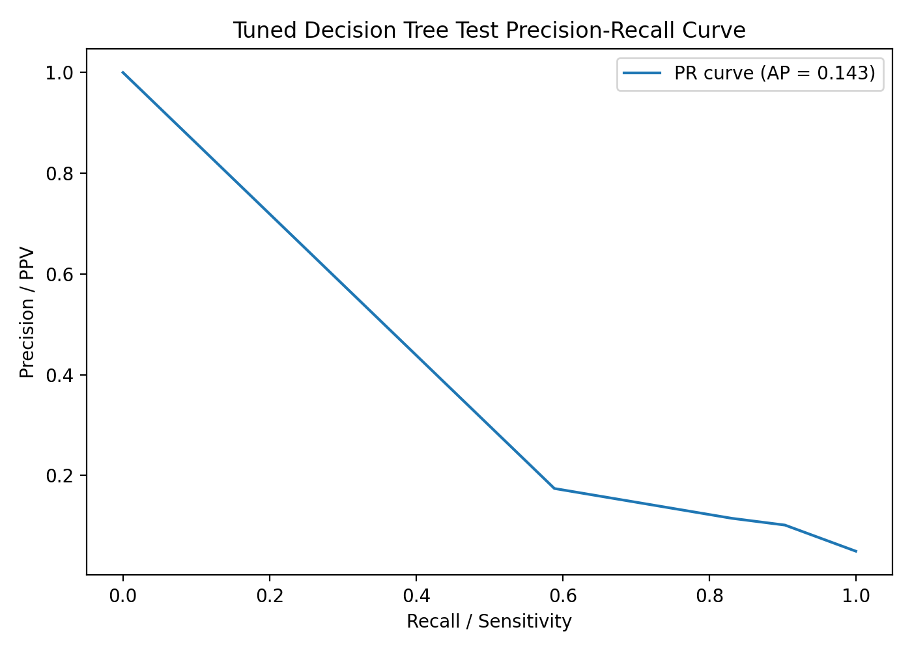

D. Exploratory ROC-based threshold and metrics
Metric | Value
Exploratory ROC-based threshold | 0.609383
Sensitivity at threshold | 0.8306
Specificity at threshold | 0.6654
Youden's J | 0.4960
The exploratory ROC-based threshold was selected directly from the test ROC curve using Youden’s J. It should not be treated as a finalized clinical threshold. A stronger workflow would select the threshold using training cross-validation or a validation dataset, then evaluate once on the untouched test set.

E. Threshold comparison table
Threshold | Accuracy | Sensitivity / Recall | Specificity | Precision / PPV | F1-score | Balanced accuracy | TN | FP | FN | TP
0.1000 | 0.5978 | 0.9032 | 0.5817 | 0.1016 | 0.1827 | 0.7425 | 1377.0 | 990.0000 | 12.0000 | 112.0000
0.2000 | 0.5978 | 0.9032 | 0.5817 | 0.1016 | 0.1827 | 0.7425 | 1377.0 | 990.0000 | 12.0000 | 112.0000
0.3000 | 0.5978 | 0.9032 | 0.5817 | 0.1016 | 0.1827 | 0.7425 | 1377.0 | 990.0000 | 12.0000 | 112.0000
0.4000 | 0.6736 | 0.8306 | 0.6654 | 0.1151 | 0.2022 | 0.7480 | 1575.0 | 792.0000 | 21.0000 | 103.0000
0.5000 | 0.6736 | 0.8306 | 0.6654 | 0.1151 | 0.2022 | 0.7480 | 1575.0 | 792.0000 | 21.0000 | 103.0000
0.6094 | 0.6736 | 0.8306 | 0.6654 | 0.1151 | 0.2022 | 0.7480 | 1575.0 | 792.0000 | 21.0000 | 103.0000

F. Confusion matrices at threshold 0.50 and exploratory threshold
Threshold | TN | FP | FN | TP
0.50 | 1575 | 792 | 21 | 103
Exploratory ROC-based | 1575 | 792 | 21 | 103

G. Comparison with default decision tree test performance
Model | Accuracy | Sensitivity | Specificity | Precision | F1 | Balanced accuracy | ROC-AUC | PR-AUC | TN | FP | FN | TP
Default Decision Tree (test, threshold 0.50) | 0.9161 | 0.1855 | 0.9544 | 0.1756 | 0.1804 | 0.5699 | 0.5699 | 0.0731 | 2259 | 108 | 101 | 23
Tuned Class-Weighted Decision Tree (test, threshold 0.50) | 0.6736 | 0.8306 | 0.6654 | 0.1151 | 0.2022 | 0.7480 | 0.8029 | 0.1426 | 1575 | 792 | 21 | 103

H. Comparison with training cross-validation performance
Metric | Training CV | Test at threshold 0.50
Sensitivity / Recall | 0.9113 | 0.8306
Specificity | 0.6572 | 0.6654
Precision / PPV | 0.1223 | 0.1151
F1-score | 0.2156 | 0.2022
Balanced accuracy | 0.7843 | 0.7480
ROC-AUC | 0.8120 | 0.8029
PR-AUC | 0.1382 | 0.1426

I. Top transformed-feature importance
Transformed feature | Importance
age | 1.0000
hypertension | 0.0000
heart_disease | 0.0000
avg_glucose_level | 0.0000
bmi | 0.0000
Gender_Female | 0.0000
Gender_Male | 0.0000
ever_married_No | 0.0000
ever_married_Yes | 0.0000
work_type_Govt_job | 0.0000

Grouped original-variable importance
Original variable | Grouped importance
age | 1.0000
Gender | 0.0000
Residence_type | 0.0000
avg_glucose_level | 0.0000
bmi | 0.0000
ever_married | 0.0000
heart_disease | 0.0000
hypertension | 0.0000
smoking_status | 0.0000
work_type | 0.0000

Tree plot and rules
Because the tuned tree is shallow, the full tree was plotted and the text rules were exported.
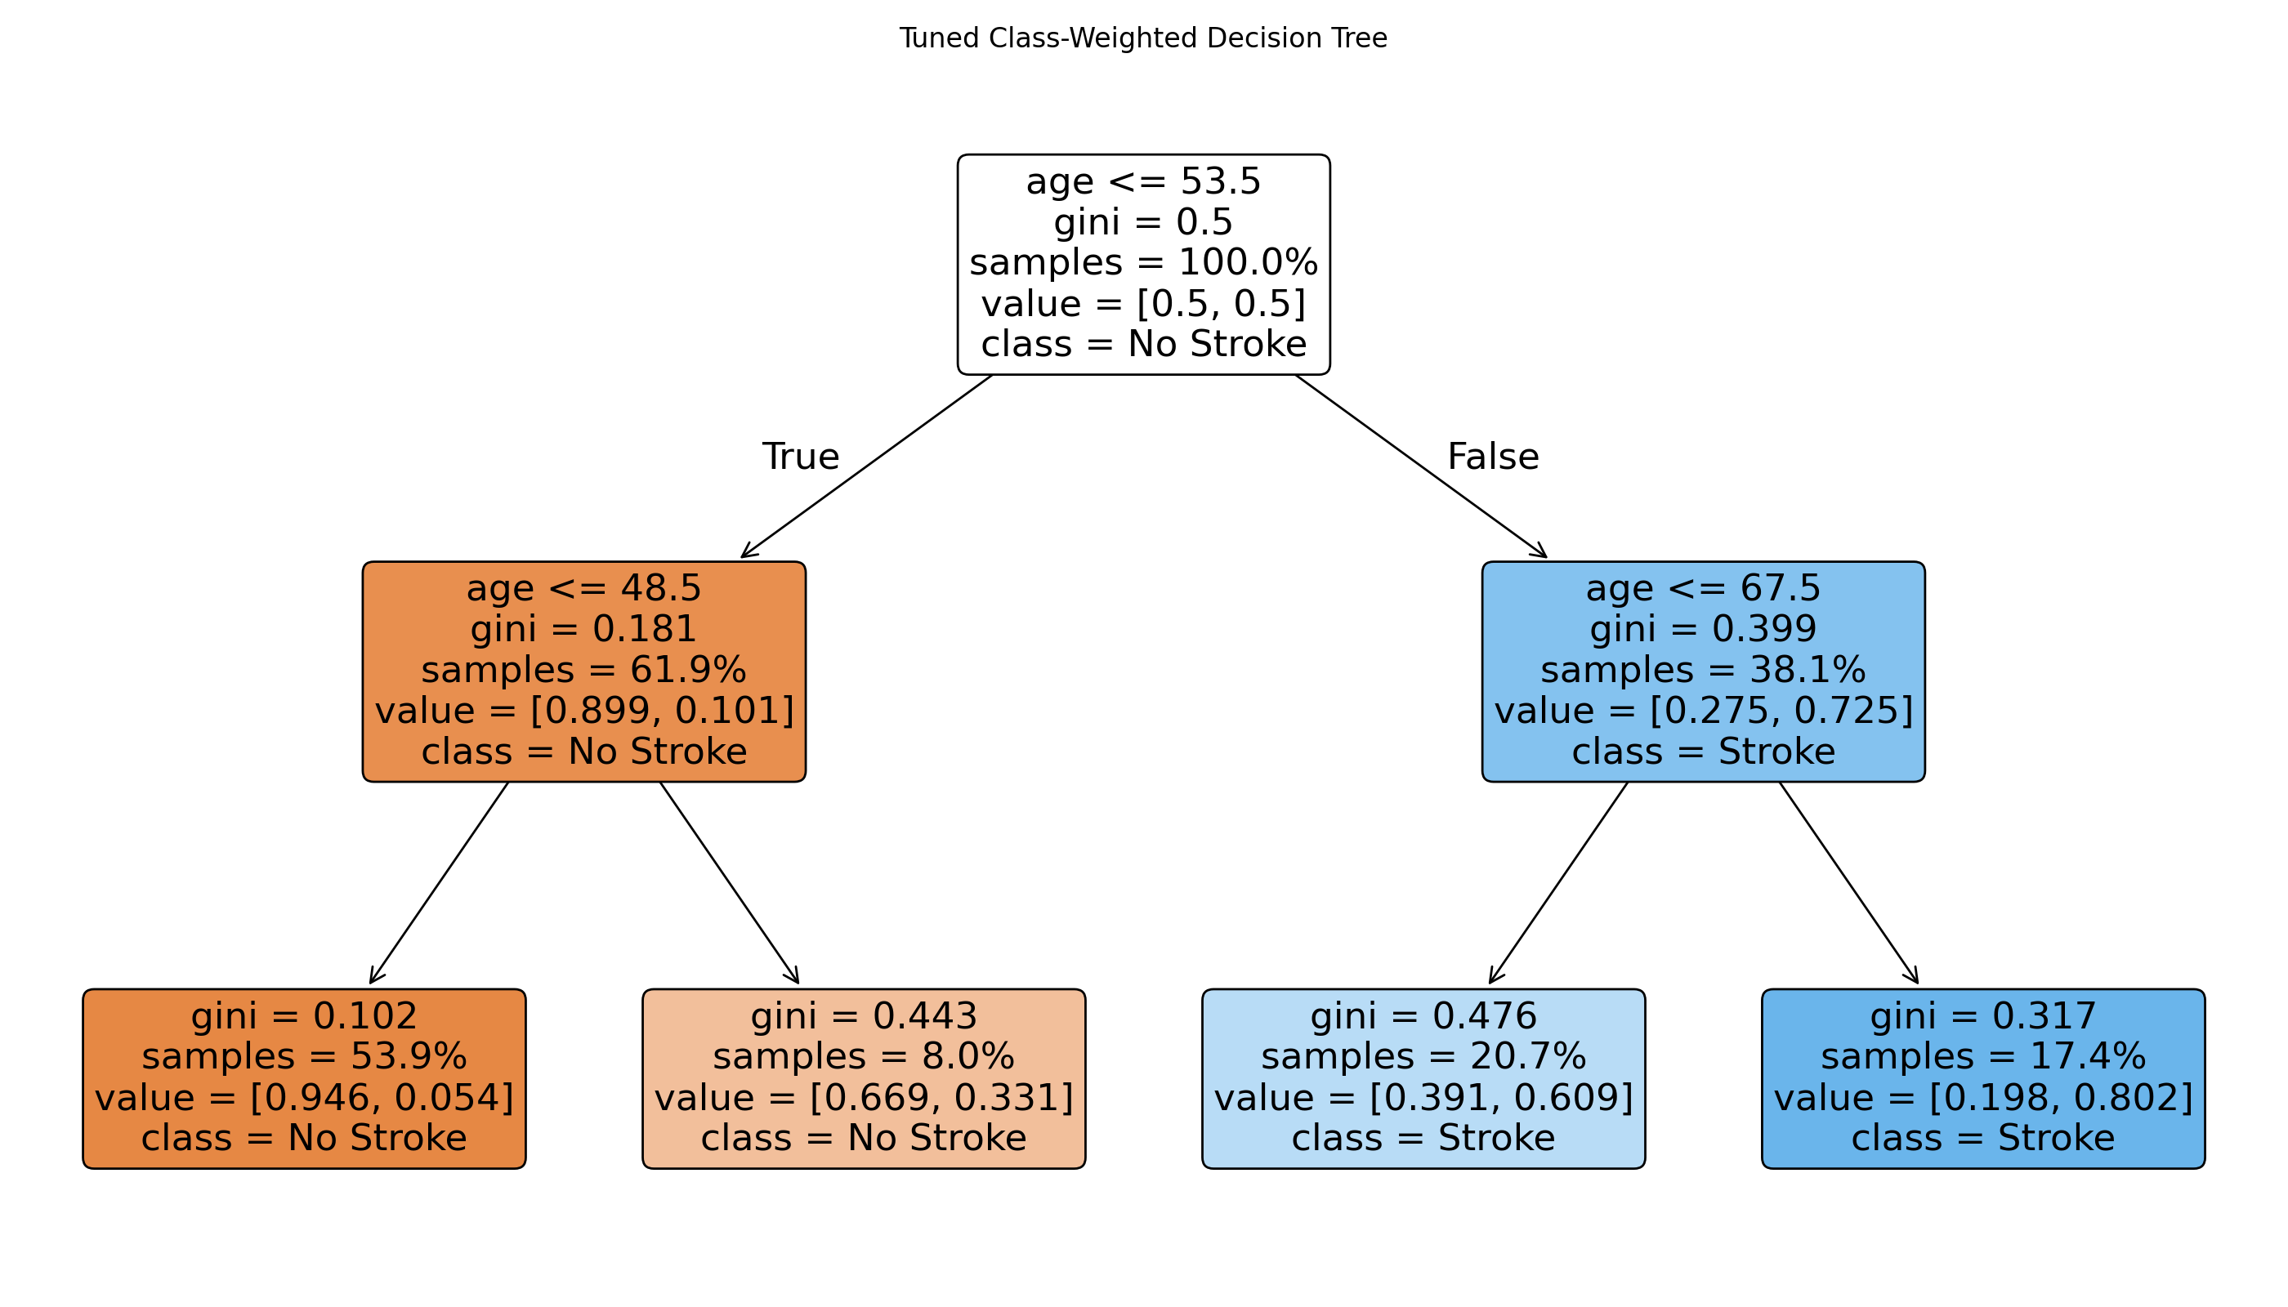
|--- age <= 53.500
| |--- age <= 48.500
| | |--- class: 0
| |--- age > 48.500
| | |--- class: 0
|--- age > 53.500
| |--- age <= 67.500
| | |--- class: 1
| |--- age > 67.500
| | |--- class: 1

J. Interpretation of sensitivity improvement and tradeoffs
- Test sensitivity improved substantially compared with the default tree: 0.8306 for the tuned tree versus 0.1855 for the default tree. The tuned model identified 103 of 124 stroke cases, compared with 23 of 124 for the default tree.
- The tradeoff was lower specificity and many more false positives. Specificity decreased from 0.9544 to 0.6654, and false positives increased from 108 to 792.
- Compared with training cross-validation, the tuned model generalized reasonably in discrimination and sensitivity. Test ROC-AUC was 0.8029 versus CV ROC-AUC 0.8120, and test sensitivity was 0.8306 versus CV sensitivity 0.9113. Test precision remained low at 0.1151 because stroke cases are rare.
- The exploratory ROC-based threshold was 0.6094 and produced the same classifications as threshold 0.50 because of the discrete probability outputs from the shallow tree. It is exploratory and should not be treated as a clinical threshold.
- The tuned model is more useful than the default tree as a screening-support model because it misses far fewer stroke cases. However, it would generate many false positives and is not clinically ready as a standalone diagnostic model.
- Feature importance indicates that age was the only splitting variable in this tuned tree. This is model-associated importance only, not causation or statistical significance.

K. Files saved
- tuned_decision_tree_test_metrics.csv
- tuned_decision_tree_test_threshold_metrics.csv
- tuned_decision_tree_test_predictions.csv
- tuned_decision_tree_test_roc_curve.png
- tuned_decision_tree_test_precision_recall_curve.png
- tuned_decision_tree_plot.png
- tuned_decision_tree_rules.txt
- tuned_decision_tree_test_feature_importance.csv
- tuned_decision_tree_test_grouped_feature_importance.csv
- tuned_vs_default_decision_tree_test_comparison.csv
- decision_tree_step8_tuned_test_evaluation_code.py

Final Decision Tree Analysis Summary

Prompt Added for This Update
Write the final decision tree analysis summary, comparing the default and tuned/pruned trees, directly answering the research question using model-associated predictors, and explaining why the tuned tree is preferable for screening sensitivity but not clinically ready due to low precision and many false positives.

Direct Answer to the Research Question
Research question: “What factors have the most significant influence or relationship to brain stroke probability?”
Based on the decision tree analyses, the most important model-associated predictors of brain stroke probability were age, average glucose level, BMI, smoking status, work type, residence type, hypertension, and heart disease. The default unpruned tree distributed importance across several variables, especially average glucose level, BMI, and age. The tuned/pruned class-weighted tree used only age for splitting, making age the dominant predictor in the simplified screening-focused model.
These findings should be interpreted as model-associated relationships, not causal effects. The analysis does not prove that these factors cause stroke, and no statistical significance testing was performed for the decision tree feature importance values.

Default Decision Tree Summary
The default decision tree was trained without pruning, tuning, class weighting, or resampling. It produced a complex model with 359 total nodes, 180 leaf nodes, and a maximum depth of 18. It achieved perfect apparent training performance, which suggested severe overfitting rather than strong generalization.
Tree characteristic | Default tree
Total nodes | 359
Leaf nodes | 180
Maximum depth | 18

Training metric | Default tree
Accuracy | 1.0000
Precision | 1.0000
Recall / Sensitivity | 1.0000
Specificity | 1.0000
ROC-AUC | 1.0000
PR-AUC | 1.0000

On the test dataset, the default decision tree performed poorly for stroke detection. Although accuracy and specificity were high, the model detected only 23 of 124 stroke cases and missed 101 stroke cases. For stroke prediction, this low sensitivity is a serious limitation because false negatives represent patients who may be at elevated stroke risk but were not flagged by the model.
Test metric | Default tree
Accuracy | 0.9161
Sensitivity / Recall | 0.1855
Specificity | 0.9544
Precision | 0.1756
F1-score | 0.1804
ROC-AUC | 0.5699
PR-AUC | 0.0731
TN | 2,259
FP | 108
FN | 101
TP | 23

Tuned/Pruned Decision Tree Summary
To reduce overfitting and improve stroke-case detection, a tuned/pruned class-weighted decision tree was selected using training cross-validation only. The selected tree was shallow, with 7 total nodes, 4 leaf nodes, and maximum depth of 2. It used age as the only splitting variable, making age the dominant model-associated predictor in this simplified decision tree.
Hyperparameter | Selected value
class_weight | balanced
max_depth | 2
ccp_alpha | 0.0
random_state | 42

Tree characteristic | Tuned/pruned tree
Total nodes | 7
Leaf nodes | 4
Maximum depth | 2

Default vs Tuned/Pruned Test Comparison
Metric | Default tree | Tuned/pruned tree
Accuracy | 0.9161 | 0.6736
Sensitivity / Recall | 0.1855 | 0.8306
Specificity | 0.9544 | 0.6654
Precision | 0.1756 | 0.1151
F1-score | 0.1804 | 0.2022
ROC-AUC | 0.5699 | 0.8029
PR-AUC | 0.0731 | 0.1426
TN | 2,259 | 1,575
FP | 108 | 792
FN | 101 | 21
TP | 23 | 103

The tuned/pruned tree was clearly better for screening sensitivity. It identified 103 of 124 stroke cases, compared with only 23 of 124 for the default tree. The most important improvement was the reduction in false negatives from 101 to 21.
Error type | Default tree | Tuned/pruned tree
False negatives | 101 | 21
False positives | 108 | 792

Why the Tuned/Pruned Tree Is Preferable for Screening
The tuned/pruned tree is preferable if the goal is early stroke-risk screening because it prioritizes sensitivity. In screening, missing a potential stroke-risk case can be clinically serious. The tuned tree improved sensitivity from 18.55% to 83.06% and improved ROC-AUC from 0.5699 to 0.8029, meaning it ranked stroke and non-stroke patients more effectively than the default overfit tree.

Why the Tuned/Pruned Tree Is Not Clinically Ready
Despite improved sensitivity, the tuned/pruned tree is not clinically ready. Its precision was only 0.1151, meaning that among patients predicted as stroke-positive, only about 11.5% were actual stroke cases in the test dataset. The model produced 792 false positives. This false-positive burden could lead to unnecessary follow-up, patient anxiety, clinical workload, and inefficient use of healthcare resources.
The model should therefore be viewed only as a screening-support model. It may help flag patients for additional review, but it should not be used alone to determine clinical diagnosis, treatment, or risk status.

Interpretation of Model-Associated Predictors

Age
Age was the most important predictor in the tuned/pruned tree and the only variable used for splitting. This indicates that the model found age to be the strongest single variable for separating higher- and lower-risk patient groups.

Average glucose level
Average glucose level had the highest transformed-feature importance in the default tree, suggesting that glucose helped the complex model separate stroke from non-stroke cases. It was not used in the final shallow tuned tree.

BMI
BMI was highly important in the default tree, but because that model overfit, its importance should be interpreted cautiously.

Smoking status, hypertension, and heart disease
These variables contributed to the default tree but were not used by the tuned shallow tree. This does not mean they are clinically unimportant; it only means age provided the dominant splitting information in the selected tuned decision tree.

Final Conclusion
The decision tree analysis showed that the default decision tree overfit the training data and failed to detect most stroke cases on the test dataset. Although it had high test accuracy and specificity, its sensitivity was only 18.55%, making it unsuitable for stroke screening. The tuned/pruned class-weighted decision tree was much simpler and substantially improved stroke detection, increasing test sensitivity to 83.06% and ROC-AUC to 0.8029. This makes the tuned tree preferable as a screening-support model because it missed far fewer stroke cases. However, the tuned tree also produced many false positives and had low precision, so it is not clinically ready and should not be used as a standalone diagnostic model. Its results should be interpreted as model-associated patterns, not causal or statistically significant findings. Further validation, calibration assessment, external testing, and comparison with additional models are needed before considering any real-world clinical use.

